**LAB ASSIGNMENT 02:**

**Question 01:**

import java.util.Scanner;

import java.util.ArrayList;

public class Main {

public static void main(String[] args) {

ArrayList<String> arr= new ArrayList<String>();

arr.add("a");

arr.add("b");

arr.add("c");

arr.add("x");

arr.add("y");

arr.add("z");

ArrayList<String> ar1= new ArrayList<String>();

ar1.add("d");

ar1.add("e");

ar1.add("f");

ArrayList<String> ar2= new ArrayList<String>();

if(arr.size()==ar1.size()){

for(int x=0;x< arr.size();x++){

ar2.add(arr.get(x));

ar2.add(ar1.get(x));

}

}

else if(arr.size()>ar1.size()) {

for(int x=0;x<ar1.size();x++){

ar2.add(arr.get(x));

ar2.add(ar1.get(x));

}

for(int x=ar1.size();x<arr.size();x++){

ar2.add(arr.get(x));

}

}

Else{

for(int x=0;x<arr.size();x++){

ar2.add(arr.get(x));

ar2.add(ar1.get(x));

}

for(int x=arr.size();x<ar1.size();x++){

ar2.add(ar1.get(x));

}

}

System.out.println(ar2);

}

}

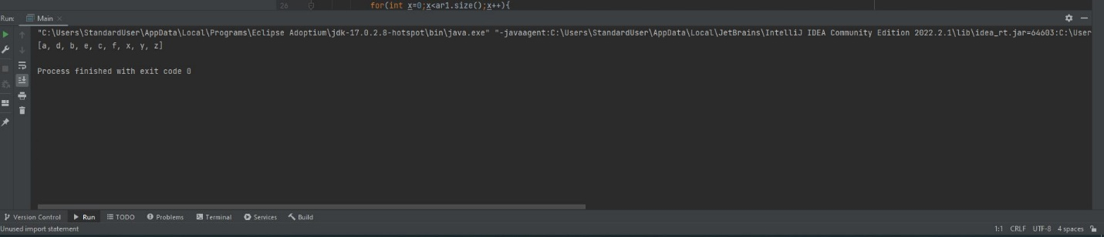

**Question 02:**

import java.util.*;

public class Main{

public static void main(String[] args) {

int[][]s=new int[10][2] ;

Scanner t=new Scanner(System.in);

int[] g=new int[10];

System.out.println("marks of students out of 100 = ");

System.out.println("1st insert number and student's marks = ");

for(int i=0;i<10;i++){

for(int j=0;j<2;j++){

s[i][j]=t.nextInt();

if(j==1){

g[i]=s[i][j];

}

}

}

char[] digit=new char[10];

for(int i=0;i<10;i++){

if(g[i]>=50){

if(g[i]>=60){

if(g[i]>=70){

if(g[i]>=80){

digit[i]='A';

}

else{

digit[i]='A';

}

}

else{

digit[i]='B';

}

}

else{

digit[i]='C';

}

}

else{

digit[i]='F';

}}

System.out.println("Student no.-----Marks-----------Grade");

for(int n=0;n<10;n++){

for(int m=0;m<2;m++){

System.out.print(s[n][m]+" ");

if(m==1){

System.out.print(digit[n]);

}

}

System.out.println();

}

}

}

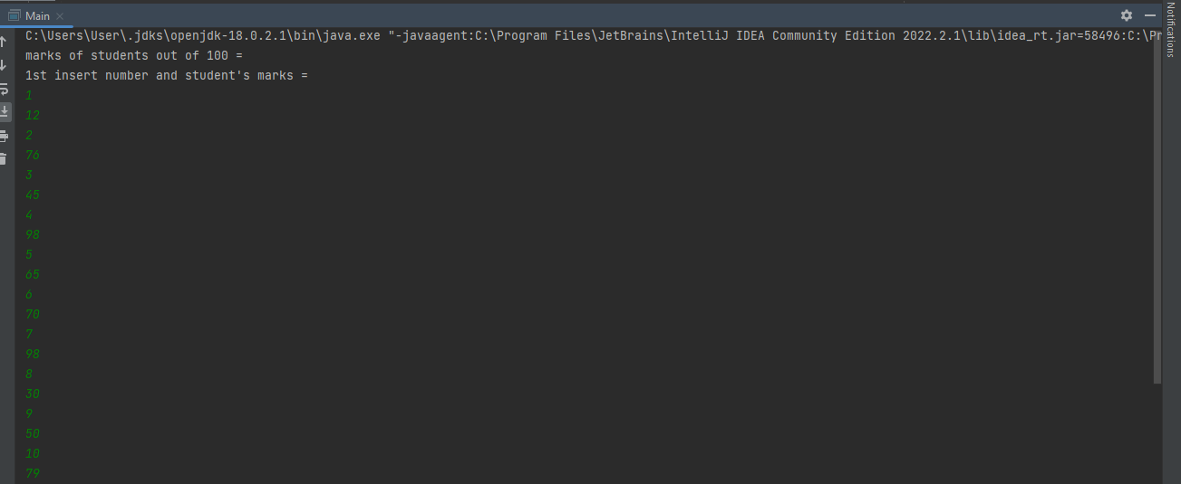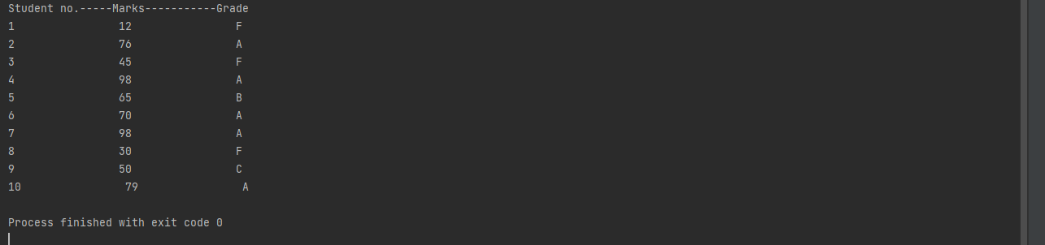

**Question 03:**

**import java.util.Scanner;**

**public class Main {**

**public static void main(String[] args) {**

**Scanner s=new Scanner(System.in);**

**System.out.println("array size = ");**

**int q=s.nextInt();**

**int[] x=new int[q];**

**int[] y=new int[q];**

**System.out.println("Enter no. = ");**

**for(int i=0; i<q; i++){**

**x[i]=s.nextInt();**

**}**

**int t;**

**for(int i=0;i<q;i++){**

**for(int j=1;j<(q-i);j++){**

**if(x[j-1]<x[j]){**

**t=x[j-1];**

**x[j-1]=x[j];**

**x[j]=t;**

**}**

**}**

**}**

**int l=0,h=q-1;**

**for(int i=0;i<q;i++){**

**if(i%2!=0){**

**y[i]=x[l];**

**l++;**

**}**

**else{**

**y[i]=x[h];**

**h--;**

**} }**

**System.out.println("Array = ");**

**for(int i=0; i<q; i++) {**

**System.out.print(" "+y[i]);**

**}**

**}**

**}**

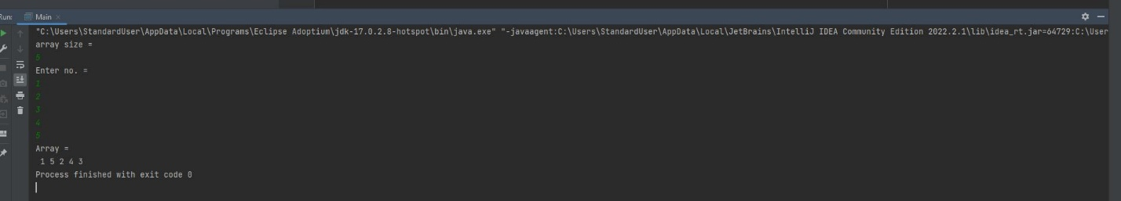

**Question 04(a):**

import java.util.Scanner;

public class Main {

public static void main(String[] args) {

Scanner t=new Scanner(System.in);

System.out.print("Number = ");

int n=t.nextInt();

System.out.print("Reversed no. = ");

reverse(n); }

public static int reverse(int no){

if(no<=0){

return no; }

System.out.print(no%10);

return reverse(no/10);

}}

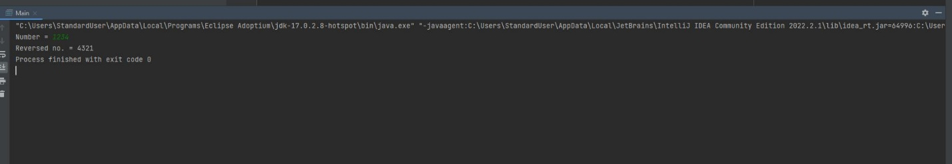

**Question 04(b):**

import java.util.*;

public class Main{

static int[]arr= {2, 4, 6 , 5, 3, 2, 6};

static int i,x=0,c;

public static void double_check()

{

while(x!=7){

c=0;

for(int k=0;k<7;k++)

{

if(arr[k]==arr[x])

{

c++;

}

}

System.out.println(arr[x]+" appeared "+c+" times");

x++;

double_check();

}

}

public static void main (String[] args)

{

double_check();

}

}

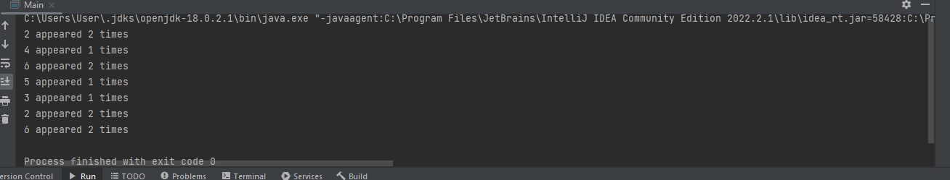

**Question 04(c):**

import java.util.*;

public class Main {

public static void main(String[] args) {

Scanner t=new Scanner(System.in);

System.out.print("Insert Number = ");

System.out.println("Obtained Result is = " + function(t.nextInt()));

}

public static int function(int r) {

if(r<=0){

return r; }

int result=r%10+function(r/10);

return result;

}

}

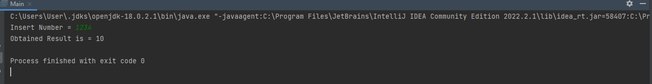

**Question 05:**

import java.util.Scanner;

import java.util.ArrayList;

public class Main {

public static void main(String[] args) {

Scanner t=new Scanner(System.in);

ArrayList<String>arr=new ArrayList<>();

System.out.println("No. of words = ");

int n=t.nextInt();

System.out.println("Words = ");

for(int x=0;x<n;x++){

arr.add(t.next());

}

System.out.println("Word limit = ");

int p=t.nextInt();

int q;

for(int y=0;y<n;y++){

q=arr.get(y).length();

if(q<p){

arr.remove(y);

y--;

n--;

}

}

System.out.println(arr);

}

}

